Important Concepts:

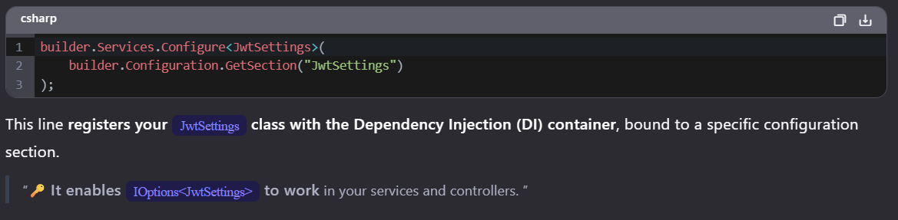

In AppSetting.json

{
"ConnectionStrings": {
"BookStoreDB": "Server=(localdb)\\ProjectModels;Database=BookStoreDB;Integrated Security=True"
},
“JwtSettings”: {
“Issue” : “Kotasai”,
“Expire” : 60
}
}

From here if we want access the data from Appsettings.json
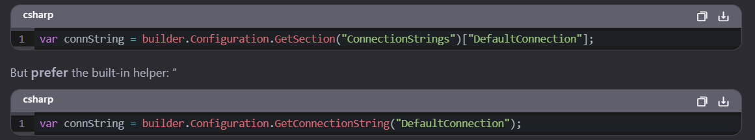

If you want to enable the dependency for that Particular data available in Appsettings.json then we need to configure
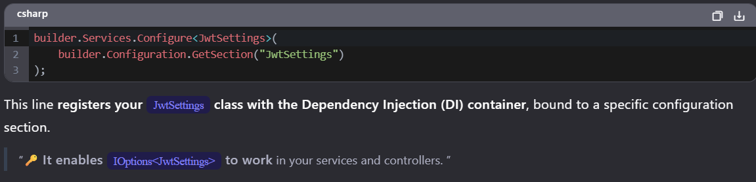

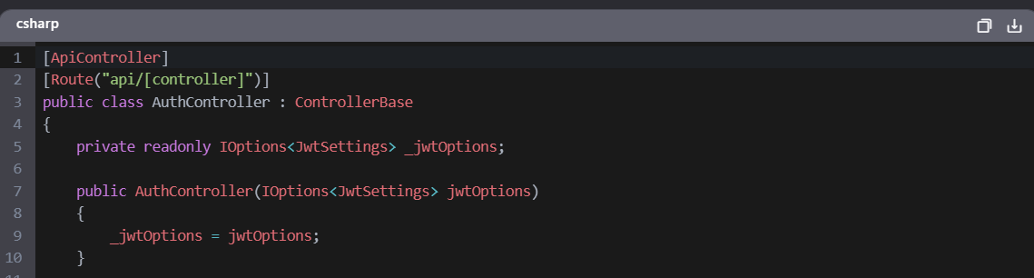
For injecting that data we need to use Ioption.
If we want to enable the DI using addsingleton we can follow below approach
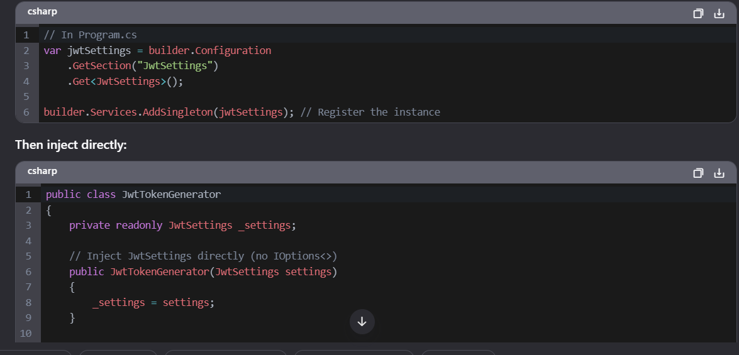

Default access modifiers for different declaration types:

